**Game Library Database – User Manual**

Instructions describe general program usage

Nicholas Sphar, Jose Rosario-Lopez, and Timmy Yip

**IS 380**

May 1, 2017

Table of Content

Setup 4

Main Menu 4

User Administration 5

Adding a User: 5

Find, Update, or Delete an Existing User 6

Game Administration 8

Add a Game 8

Find, Update, or Delete an Existing Game 8

Loan Administration 11

Adding a New Loan 11

Viewing Loans 12

Extending or Returning a Loan 13

Game Copy Administration 14

Adding and Removing Copies of a Game from the Library 14

List of Figures

Figure 1: Home screen. 4

Figure 2: Add User window. 5

Figure 3: Search User window. 6

Figure 4: Search User, selecting a user. 6

Figure 5: User Information window. 7

Figure 6: Result of user's information search. 7

Figure 7: Adding a new game window. 8

Figure 8: Searching the database window. 9

Figure 9: Searching the game database by Game Title. 9

Figure 10: Game information returned after searching the database. 10

Figure 11: Output of game title, Publisher, Designer, and categories for the game. 10

Figure 12: Adding a new loan window. 11

Figure 13: Adding a new loan based on Customer number. 12

Figure 14: Viewing all current loans in the database. 12

Figure 15: Extending the customer's loan. 13

Figure 16: Game information window. 14

## Setup

1. Open the XAMPP control panel and start MySQL and Apache.
2. Click the Admin button for Apache.
3. On the website click phpMyAdmin at the top right.
4. Click the Import Button in the header at the top.
5. Choose the gamesdb.sql file and then click go at the bottom.
6. Gamesdb should now be listed among the databases at the left.
7. Locate GameLibraryDB.jar and run it.

Default Database Username and Password

While installation may vary across different platforms and software, the default username and password is as follow:

* Username = root
* Password = (leave blank)

## Main Menu

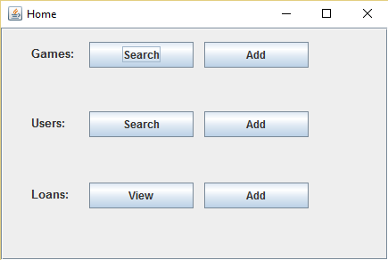

Figure 1: Home screen.

The Main Menu provides easy access to the functions of the database program. You can add or search for existing games or users, and you can view or add loans. To exit, click the X at the top right.

### User Administration

### Adding a User:

1. From the main menu, click the Add button for users.

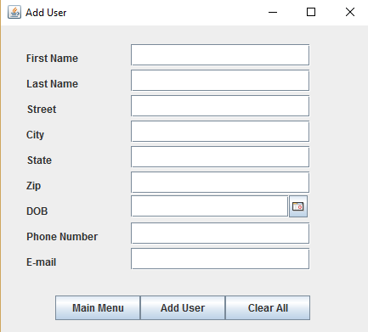

Figure 2: Add User window.

1. Enter the user’s information and click the Add User button.
2. When you are done adding users, click the Main Menu button.

### Find, Update, or Delete an Existing User

1. From the Main Menu, click the search button for users.

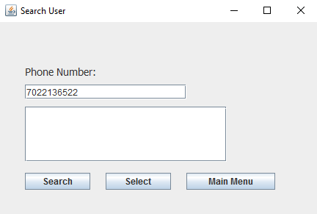

Figure 3: Search User window.

1. Enter the customers phone number with no spaces or dashes (example given above). Next, click the Search button.

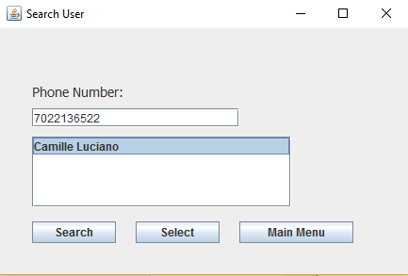

Figure 4: Search User, selecting a user.

1. Select the user’s name and then click the Select button.

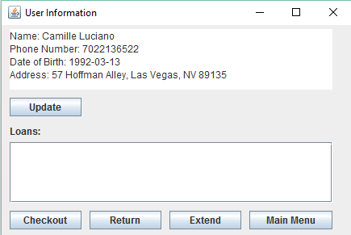

Figure 5: User Information window.

1. The user’s information, including any existing loans, is shown here. To update, click the Update button.

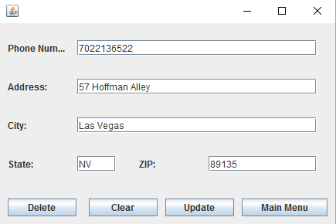

Figure 6: Result of user's information search.

1. Make any needed changes and then click the Update button.
2. To delete the user, click the Delete button.
3. When you are finished, click the Main Menu button.

## Game Administration

### Add a Game

1. From the Main menu, click the Add button for games.

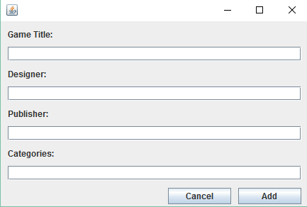

Figure 7: Adding a new game window.

1. Enter the information for the game and then click the Add button to add it to the database.

### Find, Update, or Delete an Existing Game

1. From the Main Menu, click the Search button for games.

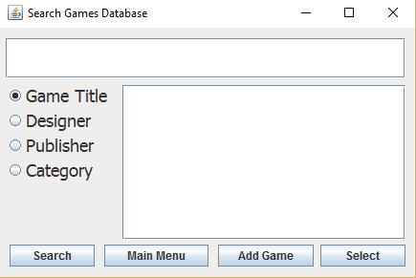

Figure 8: Searching the database window.

1. Enter search terms in the top text field and click the Search button.
   1. The default search is for game titles, but you can also search by designer, publisher, or categories of game.
   2. Partial words are ok and it is not case sensitive.

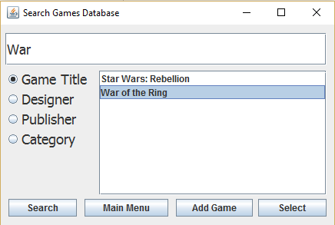

Figure 9: Searching the game database by Game Title.

1. Select the game you wish to view and then click the Select button.
   1. If you cannot locate the game and wish to add it, click the Add Game button.

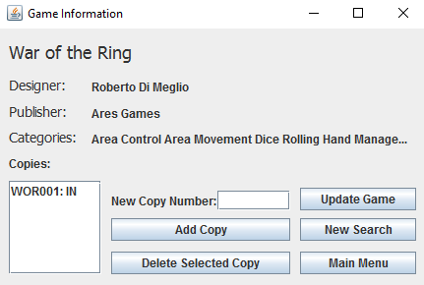

Figure 10: Game information returned after searching the database.

1. Information for the game is listed here. To update the game, click the Update Game button.’
2. Also listed here are the copies of the game in the library along with the status of whether they are in or out.

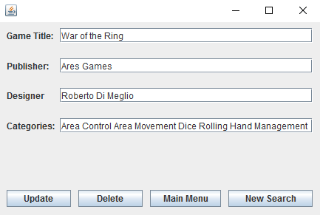

Figure 11: Output of game title, Publisher, Designer, and categories for the game.

1. Make the necessary changes and then click the Update button.
2. To delete the game, click the Delete button. This also removes all copies of the game from the inventory.

## Loan Administration

### Adding a New Loan

1. If you are sure of the user’s ID you can click the Add button for loans on the Main Menu.
2. You can also search for a user and, from the User Info screen, click the Checkout button.

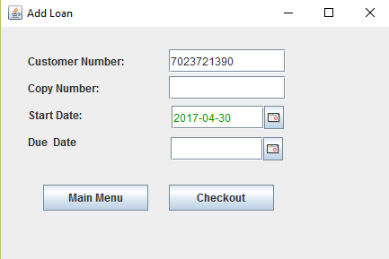

Figure 12: Adding a new loan window.

1. If you came from the Main Menu, enter the Customer Number, if you searched for the user it will appear in the field.

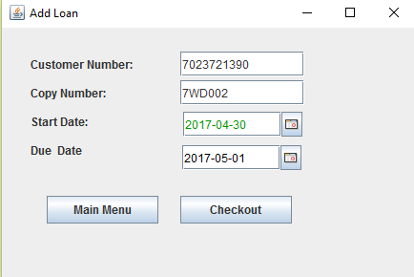

Figure 13: Adding a new loan based on Customer number.

1. Enter the copy number from the sticker on the box and enter or select the due date for this loan. Then click the Checkout button.
2. When you are finished entering new loans, click the Main Menu button.

### Viewing Loans

1. For administrative purposes you may sometimes want to view all the loans. To do this, click the View button for loans on the Main Menu.

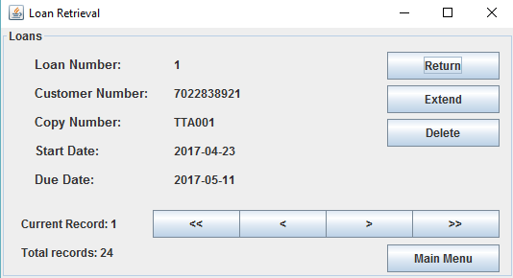

Figure 14: Viewing all current loans in the database.

1. Here you can cycle between loans and return, extend, or delete them as needed.

### Extending or Returning a Loan

1. Follow the steps for locating a user listed above.

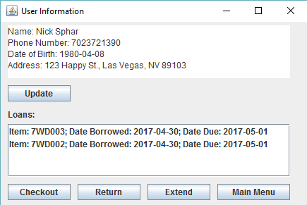

Figure 15: Extending the customer's loan.

1. On the User Information screen, outstanding loans are listed.
2. To return an item, click the correct loan and the click the Return button, make sure the sticker on the box matches the loan.
3. To extend a loan for an additional day, click the Extend button.

## Game Copy Administration

### Adding and Removing Copies of a Game from the Library

1. Follow the steps above for locating the game information.

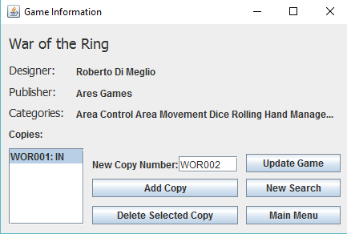

Figure 16: Game information window.

1. To add a copy of the game, enter the new copy number in the field and click the Add Copy button.
   1. The general format is the first letters of three of the words followed by the number of this copy.
   2. If the title is two words, it is the first letter of the first word and the first two letters of the second word.
   3. If the title is one word, it is the first three letters of the word.
2. To delete a copy, select the copy from the list and click the Delete Selected Copy button.